# 

# **Assessment # 4– (15%)**

**Name :**

**ID No :**

**Section:**

The periodic signal is given by the following equation:

$$x\left(t\right)=\left\{\begin{aligned}2t^{2} 0≤t≤3 \\ 3 3≤t≤5 \\ 10-2*t 5≤t≤8\end{aligned}\right.$$

1. **Sketch x(t) either by hand in the given space below or using MATLAB. Give x, y label and title. (10 points).**

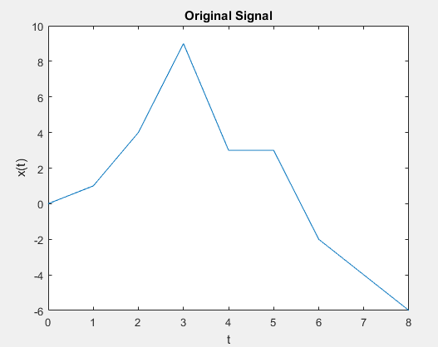

**Compute and plot for one period the approximations of $x(t)$ using**

1. **Complex Exponential Fourier Series computing 9 and 17 terms (30 points)**
2. **Trigonometric Fourier Series computing 13 and 27 terms (30 points)**

***Hint:*** Use the heaviside function in MATLAB to define $x\left(t\right)$ for each time interval.

You should get two figures at the end where each figure has three subfigures as shown below. Make sure to include comments for your code.

**Code**

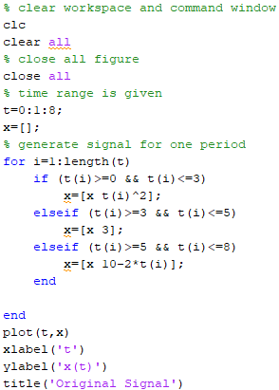

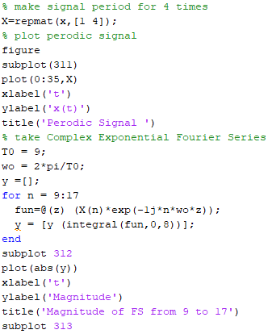

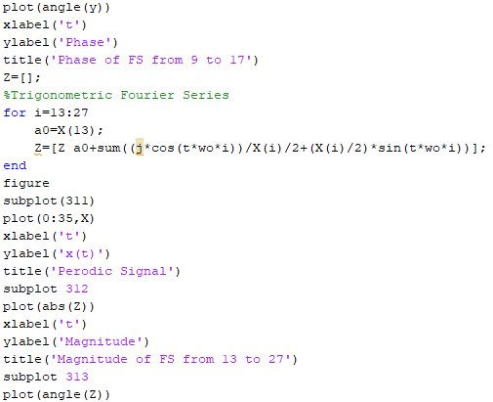

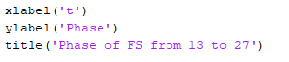

**Output**

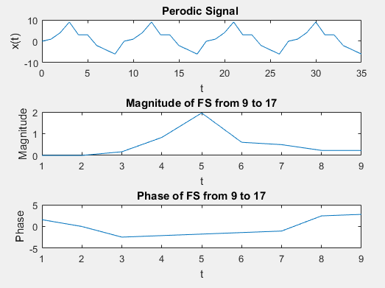

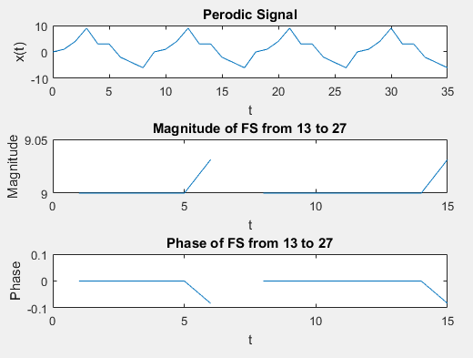

1. **For each of the code written explain it in detail. Do not just mention the commands, but write why you used the command and refer to each of the formulas (20 points)**

**Details of the code:**

In the first command I clear the workspace, command window and then all figure because may be some variable already exist in our workspace and perform wring processing. Close all figure because I want to show just current output figure, if we can’t close it than maybe some figure of previous question plot already and then we can mix it and not identity the correct output. After close all figure and clear workspace, I generate time period of the signal which is given as 0:8. After that signal is repeat. Define x(t) according to given t condition and plot the original signal. Set the axis and label as well in plot. Repmat make the signal as periodic as much we desire, so I need at lest 4 times signal as periodic because I want to process the signal at 27 value till. after the periodic signal we need to perform the complex Fourier series. for the complex Fourier series us the below formula.

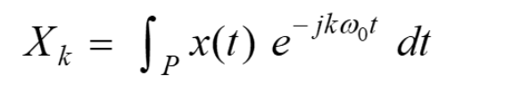

Plot the magnitude and phase response. Compute the Trigonometric Fourier Series by using the formula and plot the magnitude and phase response.



1. **Explain in detail using your own words the difference between Complex Exponential Fourier Series and Trigonometric Fourier Series. (10 points)**

The trigonometric Fourier series is a periodic function of period T0 = 2π/ω0. If the function g(t) is periodic with period T0, then a Fourier series representing g(t) over an interval T0 will also represent g(t) for all t.

A continuous time signal x(t) is said to be periodic if there is a positive non-zero value of T for which. As we know any periodic signal can be classied into harmonically related sinusoids or complex exponential, provided it satises the Dirichlet's Conditions